Firewall Tests
Running Configuration
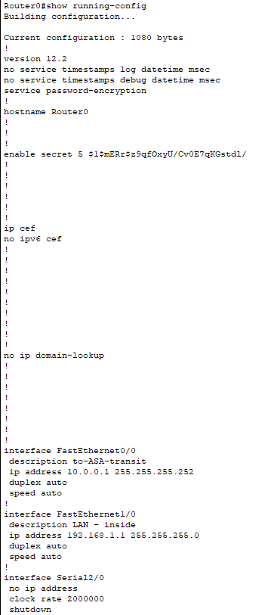
Routre0 Configurations
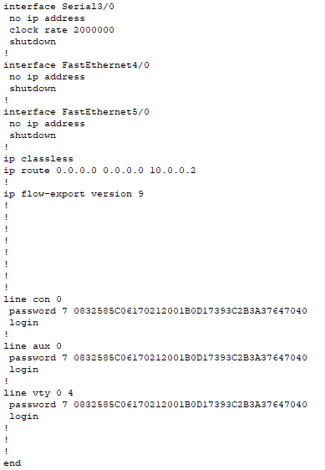
- Password on and encrypted

Switch0
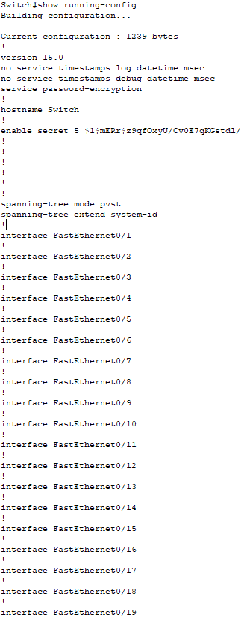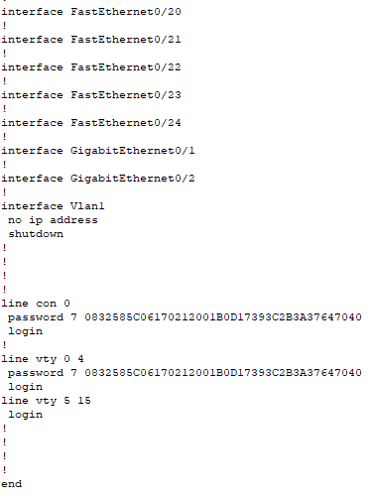

ASA0

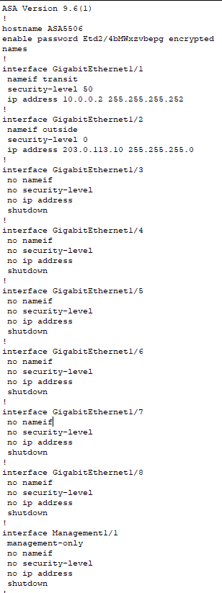

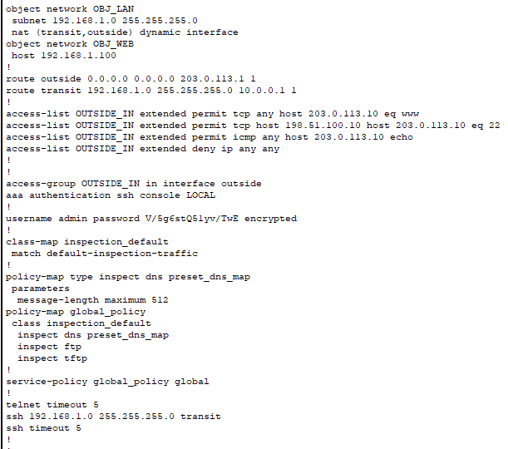
Running Configuration
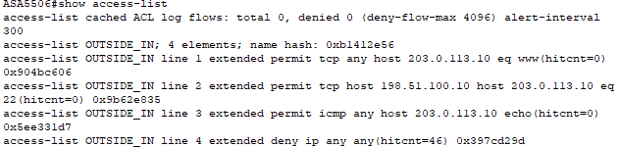
*Firewall Access-list

Internal Network

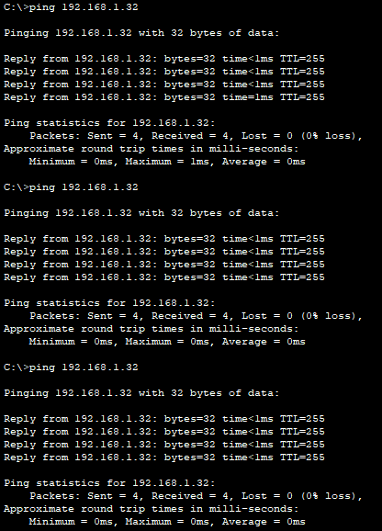
Ping from inside attacker to IoT3 Status: success

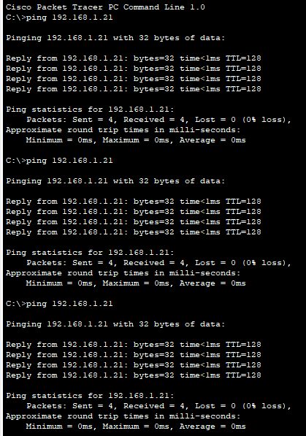
Ping from inside attacker to PC0 (admin) status: Success

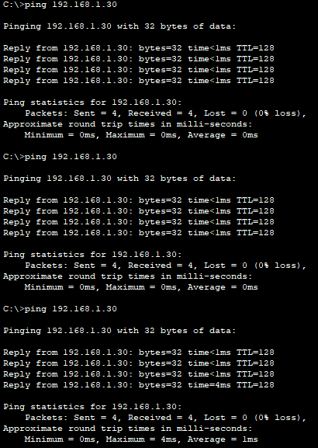
Ping from inside attacker to PC4 status: success

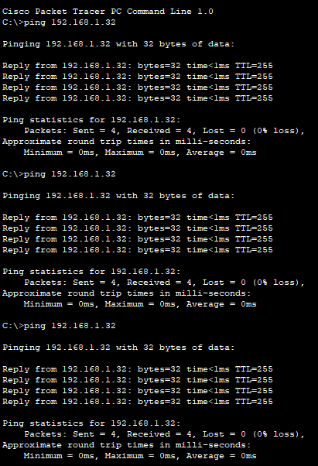
Ping Iot3 from PC0 (admin) status: success
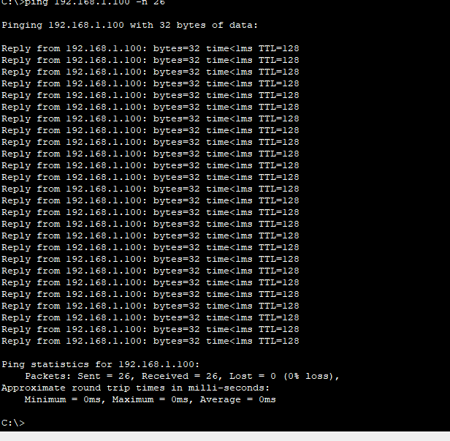
Dos from inside attacker
- ASA blocks outside traffic
- Does not filter inside traffic
- Ping between departments

Test Outside attacker
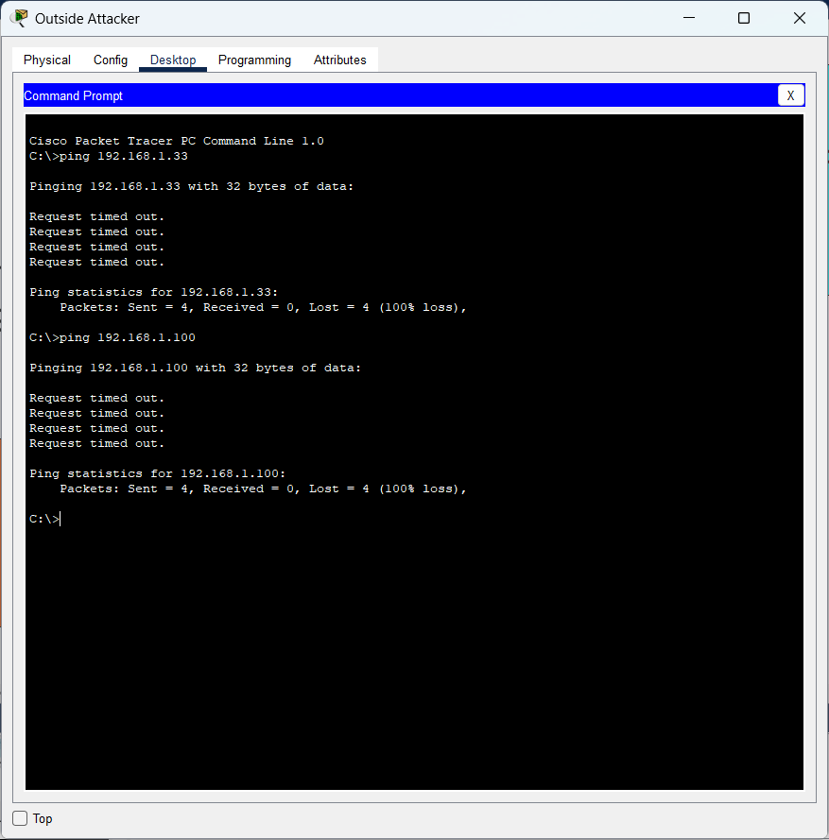
Ping from outside attacker to internal network status: failed

